Problem set 3
Solve the following questions for the problem session.
1. Consider the graph G = (V, E) depicted in Figure 1 below. Construct a weighting w : E → {1, 2} such that the weighted graph has exactly two distance-trees (shortest-path trees) rooted at a
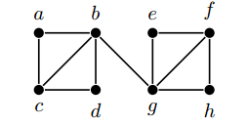
2. (a) Give an example of a strongly connected simple digraph without a directed Hamiltonian
path.
(b) Prove that a connected directed graph G is strongly connected if the out-degree d+(v, G) equals the in-degree d−(v, G) at each vertex v.
3. (a) Find the six-digit Pr¨ufer code for the following tree
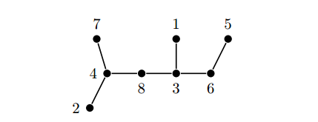
(b) Which trees have a code with only one integer occurring?
4. Let n ≥ 1.
(a) How many edges has the hypercube Qn?
(b) For what values of n, does Qn have an Euler circuit?
(c) What is the length of the longest path in Qn?

